Name : ________________________

Planning

A

[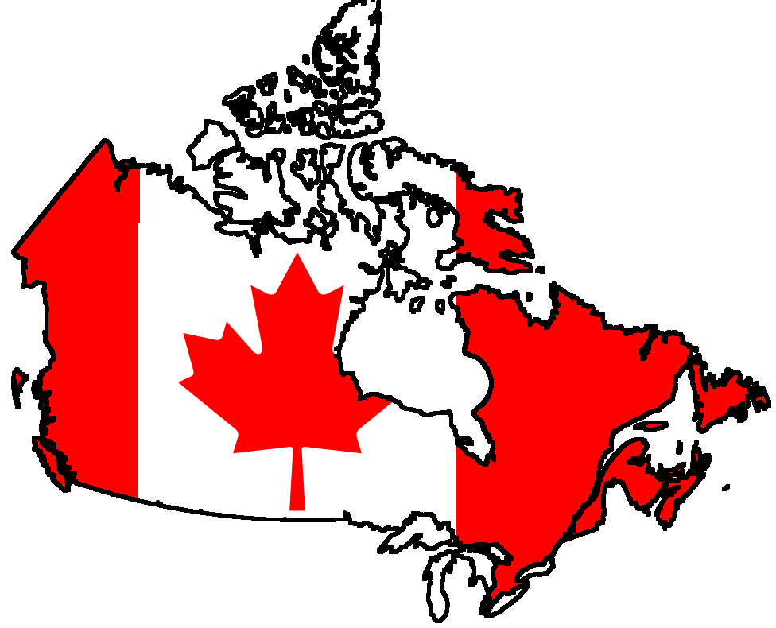](http://www.google.ca/url?sa=i&rct=j&q=canada&source=images&cd=&cad=rja&uact=8&ved=0CAcQjRw&url=http://allcanadaclean.com/safety_rules.html&ei=irZQVfuLHsWNyATwr4CwDw&bvm=bv.92885102,d.cGU&psig=AFQjCNEECrjWbaOdkeNk0JNSePfseJsHpw&ust=1431439332998789)Trip!

[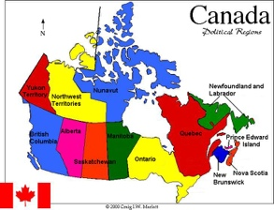](http://www.google.ca/url?sa=i&rct=j&q=Canada&source=images&cd=&cad=rja&uact=8&ved=0CAcQjRw&url=http://www.sd71.bc.ca/Sd71/Edulinks/Canada/&ei=kkVSVbnpHpK1yASY8YFo&psig=AFQjCNHb68GMYVeclzkAM2tcAlWiF3pxKA&ust=1431541474061547)It’s now time to start your final project of the year! Let’s plan a trip to a province or a territory of your choice. With your teammates, you will plan a 4-day trip somewhere in Canada. Each member must plan a complete day in a city/town! At the end, you will have to present your trip at the ITAC (the International Travel Agency Contest). The famous contest is the best opportunity for your team to present your destination and its wonders.

Step 1 Choose a Destination

Step 2 Precious Info

In order to know better the place, you will be talking about, let’s do some research! That way you will be ready to produce a great project and to answer different questions after your presentation!

Step 3 Plan the Trip

For each day, you must present a complete schedule. Here’s a list of the elements you need:

* A short description of your city/town (50 words)
* Itinerary on a map
* THE MOST interesting activity of your city
* Two other activities to do (indoor, outdoor, festivals, attractions, etc.)
* [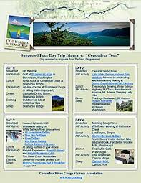](http://www.google.ca/imgres?imgurl=http://crgva.server271.com/wp-content/uploads/2014/04/Itinerary_ConossieurTour_tn.jpg&imgrefurl=http://www.crgva.org/suggested-gorge-tour-itineraries/&h=388&w=300&tbnid=tEoykef1LEhMZM:&zoom=1&q=trip+itinerary&docid=cUNcXeB8Gg7WbM&ei=zUdSVf_PFYmQoQShoICIDg&tbm=isch&ved=0CEoQMygkMCQ)Opening hours
* Entrance fee
* One place to eat
* One place to sleep
* Travel tips, etc.

Name of the city

Short description of the city,

year of creation,

geographical interests,

location. 50 words

Map

to

indicate

the place

___________________________________________________________________________________________________________________________________________________________________________

* Write about **the most interesting activity** to do with a short description of it, the price ($), the opening hours, etc. This text should be written at the simple present tense. (50 words)
* Choose two other activities to do:
* Cultural activity (museum, guided tour, etc.)
* Festival or special event
* Challenging activity
* Concert
* Outdoor activity
* Sports events
* Find a place to eat ($)
* Find a place to stay (number of stars, $, etc.)

**\*Each member must work on a different city of the chosen province/territory\***

Step 4 **The Promotional Material**

|  |  |
| --- | --- |
| **Ad** | **Business Card** |
| 1. Fill the storyboard. 2. Create your ad using the Adobe Spark Video app on an iPad.   Résultat d’images pour Spark Video | 1. Find a name for your travel agency. 2. Create a logo 3. Find a slogan 4. Team names 5. Phone number, address, email address and website link     **To create your card, use Publisher or Word.** |

Step 5 Who is Going to Do What?

|  |  |  |  |
| --- | --- | --- | --- |
| **Students** | **Task 1** | **Task 2** | **Other Tasks** |
| **Student 1: _____________________**  **City:_________________** | **Day 1** | **Brochure**  **(days 1-2-3)** |  |
| **Student 2: _____________________**  **City:_________________** | **Day 2** | **Brochure (over page, last page and day 4)** |  |
| **Student 3: _____________________**  **City:_________________** | **Day 3** | **Presentation** |  |
| **Student 4: _____________________**  **City:_________________** | **Day 4** | **Presentation** |  |

Step 6 The Brochure

You will have to create a brochure of your wonderful trip! It must be complete and appealing!

For your brochure, you can use Publisher, Word, Google docs or [Printing Press](http://www.readwritethink.org/files/resources/interactives/Printing_Press/) (online tool from Read Write and Think).

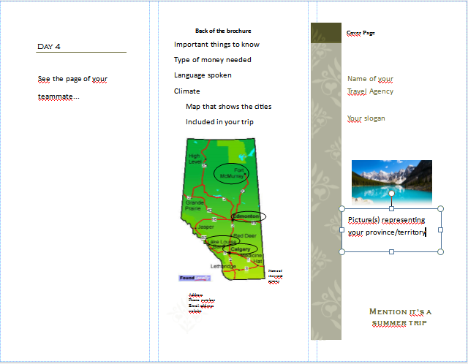

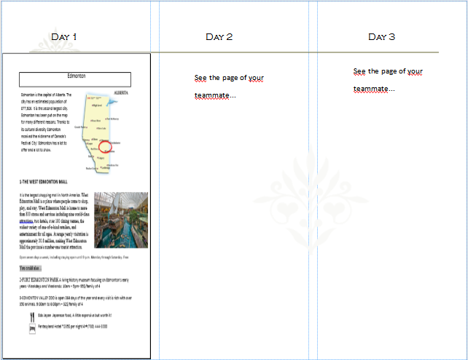

[](http://www.google.ca/url?sa=i&rct=j&q=presentation&source=images&cd=&cad=rja&uact=8&ved=0CAcQjRw&url=https://www.psychologytoday.com/blog/thinking-about-kids/201003/how-give-presentation-part-i-its-not-about-you&ei=DEdSVYfKNoiuyQTTpYHoDg&psig=AFQjCNEf7q9k76Y99DN10_I3KhGBNnTkhQ&ust=1431541831404105)Step 7 The Presentation

It’s time to write down some elements to present something unique and (you know me) original! Your presentation must last **at least 10 minutes**. Don’t forget to practise, practise and practise because reading is forbidden and will be penalized!

In order to work well in teams, the key is to separate equally the work you have to do. If you are not sure on how to do so, it will be my pleasure to guide you throughout the process.

|  |
| --- |
| Your presentation must contain: |
| 1. The destination 2. The four days 3. The itinerary on a map 4. Your ads 5. The name of your travel agency 6. Your slogan 7. The members of your team   For your presentation, you can use PowerPoint, Google docs, Smart Notebook or any other presentation tool. |

[](http://onemillionskates.com/inside-edge/mike-johnston-on-building-a-winning-team-and-how-parents-can-help/)

## Be terrific, as usual!